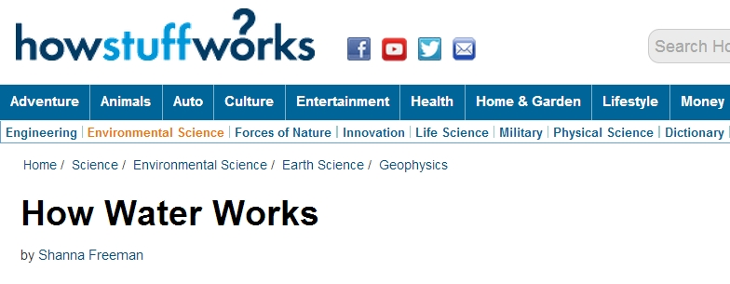
Water PropertiesThe hydrogen bond between water molecules that we talked about in the first section is the reason behind two of water's unique properties:cohesion and adhesion. Cohesion refers to the fact that water sticks to itself very easily. Adhesion means that water also sticks very well to other things, which is why it spreads out in a thin film on certain surfaces, like glass. When water comes into contact with these surfaces, the adhesive forces are stronger than the cohesive forces. Instead of sticking together in a ball, it spreads out.
Water also has a high level ofsurface tension. This means that the molecules on the surface of the water are not surrounded by similar molecules on all sides, so they're being pulled only by cohesion from other molecules deep inside. These molecules cohere to each other strongly but adhere to the other medium weakly. One example of this is the way that water beads up on waxy surfaces, such as leaves or waxed cars. Surface tension makes these water drops round so they cover the smallest possible surface area.
Capillary action is also a result of surface tension. As we mentioned, this happens in plants when they "suck up" water. The water adheres to the inside of the plant's tubes, but the surface tension attempts to flatten it out. This makes the water rise and cohere to itself again, a process that continues until enough water builds up to make gravity begin pulling it back down.
Water's hydrogen bonds are also why its solid form, ice, can float on its liquid form. Ice is less dense than water because water molecules form crystalline structures at freezing (32 degrees Fahrenheit or 0 degrees Celsius) temperatures. The thermal properties of water are also linked to its hydrogen bonds. Water has a very high specific heat capacity, which is the amount of heat per unit mass required to raise its temperature by one degree Celsius. The energy required to raise the temperature of water by one degree Celsius is 4.2 joules per gram. Water also has a high heat of vaporization, which means that it can take a lot of heat without its temperature rising much. This plays a huge part in the climate, because it means that oceans take a long time to warm up.
Water is often known as the universal solvent, which means that many substances dissolve in it. Substances that dissolve in water are hydrophilic. This means that they are as strong or stronger than water's cohesive forces. Salt and sugar are both polar, like water, so they dissolve very well in it. Substances that do not dissolve in water are hydrophobic. This is the source of the saying "oil and water don't mix." Water's solvency is why the water that we use is rarely pure; it usually has several minerals dissolved in it.
The presence of these minerals is the difference between hard water and soft water. Hard water usually contains a lot of calcium and magnesium, but may also contain metals. Soap will not lather well in hard water, but hard water isn't usually dangerous. It can also cause lime scale deposits in pipes, water heaters and toilets.
Some of the latest controversy about water's properties lies in how ice behaves when it melts. Some scientists claim that it looks about the same as it does when it's solid, except that some of its hydrogen bonds are broken. Others claim that it forms an entirely new structure. So for all of its importance, we still don't completely understand water.

Adhesion and Cohesion of Water
I used to wake up in a cold sweat in the middle of the night because I could not get the concepts of water adhesion and cohesion clear in my mind. If you have that problem, too, then do yourself a favor and read on to learn about these important properties of water.
Cohesion: Water is attracted to water
Adhesion: Water is attracted to other substances
Adhesion and cohesion are water properties that affect every water molecule on earth and also the interaction of water molecules with molecules of other substances. Essentially, cohesion and adhesion are the "stickiness" that water molecules have for each other and for other substances. You can see this in the picture to the right. The water drop is composed of water molecules that like to stick together, an example of the property of cohesion. The water drop is stuck to the end of the pine needles, which is an example of the property of adhesion. Notice I also threw in the all-important property of gravity, which is causing the water drops to roll along the pine needle, attempting to fall downwards. It is lucky for the drops that adhesion is holding them, at least for now, to the pine needle.
Cohesion makes a water drop a dropIt is easy to see that the drop seems to have a "skin" holding it into a sort of flattened sphere (although there is nothing flat about a water drop in outer space.). It turns out that this surface tension is the result of the tendency of water molecules to attract one another. The natural form of a water drop occurs in the "lowest energy state"l, the state where the atoms in the molecule are using the least amount of energy. For water, this state happens when a water molecule is surrounded on all sides by other water molecules, which creates a sphere or ball (perfectly round if it was in outer space). On Earth, the effect of gravity flattens this ideal sphere into the drop shape we see. Although you may have heard of a "skin" where water meets the air, this is not really an accurate description, as there is nothing other than water in the drop.
Why is water sticky?Water is highly cohesive—it is the highest of the non-metallic liquids. Water is sticky and clumps together into drops because of its cohesive properties, but chemistry and electricity are involved at a more detailed level to make this possible. More precisely, the positive and negative charges of the hydrogen and oxygen atoms that make up water molecules makes them attracted to each other. If you've played with bar magnets you will know that the positive (+) side of one magnet will repel the other positive side, while a negative (-) side of one magnet will attract the positive side of the other magnet. Positive charges attract negative charges.
In a water molecule, the two hydrogen atoms align themselves along one side of the oxygen atom, with the result being that the oxygen side has a slight negative charge and the side with the hydrogen atoms has a slight positive charge. Thus when the positive side on one water molecule comes near the negative side of another water molecule, they attract each other and form a bond. This "bipolar" nature of water molecules gives water its cohesive nature, and thus, its stickiness and clumpability (maybe "dropability" is a better term?).

References
Author, A. (date). "Title of Article" Home Page, <website address> Last Retrieved date
Freeman, S (October 18, 2007) "How Water Works", HowStuffWorks.com, <http://science.howstuffworks.com/environmental/earth/geophysics/h2o7.htm> Last Retrieved August 18, 2014
Perlman, H (March 17, 2014) "Adhesion & Cohesion of Water" USGS.gov <http://water.usgs.gov/edu/adhesion.html> Last Retrieved August 18, 2014

