Mass & Matter
That’s heavy man… heavy.

Mr. Beadle – Rm 202

www.vhmsscience.weebly.com
bbeadle@alpinedistrict.org

Name: _____________________________________ Period: ___________

Lab Activities | Score
Elastic Energy Experimental Design | /72

Scientific Method & Experimental Design

Experimental Test Question & Hypothesis /10
Overall Question: What is mass? What is matter?
What happens to our mass when we increase the amount of matter?

Look at the variables that you’re testing and rephrase the overall question into a testable experimental question:

How does (independent variable) affect (dependent variable)?

Investigative question: ( /4)
Example: If I change the (independent variable) then the (dependent variable) changes because…
- This statement should be a subset of a series of tests that tests the original hypothesis.
- Include what you are changing in the independent variable and how that changes the dependent variable.
- The “because” portion is the “why” behind the explanation of your possible outcomes.

Your Hypothesis: ( /6)

Experimental Design: /10
How are you going to carry out your experiment? Be sure that you set up a step by step approach detailing each set of procedures. (Think of a recipe book w. materials and procedures).

Materials  (Bullet Points, Quantities & Items) | Procedures  (1. 2. 3.)

Qualitative Observations (What you see before, during or after the experiment - min 2): /4

Data Table /20

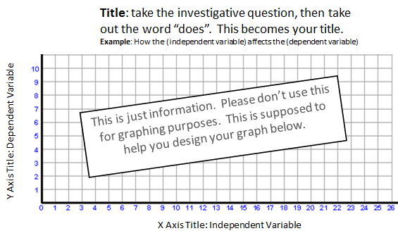
/10

Data Analysis (min 4): /8
- What is the range of your dependent data (Your high and low) and how does it compare to your independent range of data?
- What is the average of your dependent data compared to the independent data?
- What trends do you see according to your graph?
- What data points don’t seem to match up to the trends? (These “bumps” in the graph are your possible experimental errors)

Conclusion: /10
- Summarize
  - Question & Hypothesis
  - Procedures
  - Observations, Trends, Results & Data Analysis related to the question/hypothesis.
  - Experimental errors

- Final Concluding statements
  - Conclusion 1:
    - Does the data support or reject your original hypothesis?
  - Conclusion 2:
    - Explain the “why” behind the phenomenon that you witnessed and provide the reasoning to support why your hypothesis is correct or incorrect.
    - Use your findings to give deeper insights in your research.
- Next Steps:
  - How can we apply what you learned to help explain other phenomenon?
  - What is the next step in your research

