**Physics 1**

Mass, Weight & Gravity

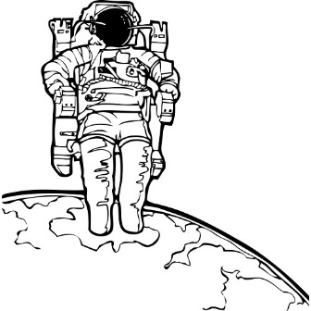

**Mr. Beadle – Rm 202**

Website: [www.vhmsscience.weebly.com](http://www.vhmsscience.weebly.com)

Email: [bbeadle@alpinedistrict.org](mailto:bbeadle@alpinedistrict.org)

Name: ___________________________________________ Period: ___________

|  |  |
| --- | --- |
| **Lab Activities** | **Score** |
| Starter Questions | / ___ |
|  |  |
| Vocabulary | /12 |
| Day 1: Part 1 | /12 |
| Part 2 | /37 |
| Part 3 | /21 |
| Day 2: Part 4 | /41 |
| Day 3: Part 5 | /44 |
| Part 6 | /17 |
| Part 7 | /31 |
| Part 8 |  |
| Theory | /20 |
| Additional Points |  |
| Total: | /235 |

**Unit Vocabulary:** (Use a dictionary or science textbook to complete the words below)

1. **Word: Mass**

/12

* 1. Definition:_____________________________________________________________________**______________________________________________________________________________________**

1. **Word: Gravity**
   1. Definition:___________________________________________________________________________________________________________________________________________________________
2. **Word: Weight**
   1. Definition:___________________________________________________________________________________________________________________________________________________________
3. **Word: Inertia**
   1. Definition:___________________________________________________________________________________________________________________________________________________________
4. **Word: Friction**
   1. Definition:___________________________________________________________________________________________________________________________________________________________
5. **Word: Force**
   1. Definition:___________________________________________________________________________________________________________________________________________________________

*Galileo's Gravitational Gauntlet*

**Part 1: Direction of gravity /12**

*Q: What direction does the force of gravity pull?*

Hypothesis:

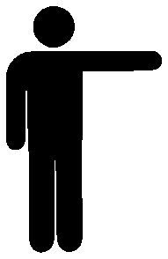**Hypothetical Tests:**

1. If I crumpled up a paper and dropped it, which direction would it fall? On the diagram, indicate with an arrow the direction it would fall and describe it below.

U.S.

Aus

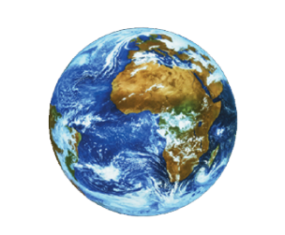

1. Imagine you were in Australia – where they are upside down relative to us. Which direction would the objects fall then? Draw the arrows indicating the direction the objects would drop. Is that the same direction that our object fell in North America?

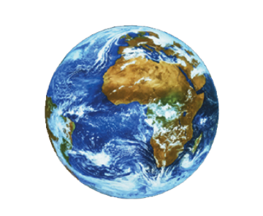

1. On the earth picture draw an arrow in the direction an object would fall on the North Pole. Draw the direction an object would fall on the South Pole. Now draw four more arrows showing the direction an object would fall on other parts of the globe. Describe what you see.
2. Now imagine there was a very wide hole which reached all the way through the earth to the other side. You later jumped in that hole; what would happen, and where would you end up at?

**Conclusion**: Based on these hypothetical tests, what did you learn about gravity and the direction of falling objects?

**Part 2: Factors that influence gravity (Lab) /37**

*Q: Does Mass influence weight?*

*Hyp*: (What do you think? Why?)

**Lab Activity Test 1**: Stand on the bathroom scale and weigh yourself with 1 book. Next, weigh yourself with 5-10 additional books. Record your findings.

|  |  |  |
| --- | --- | --- |
| Item | Weight | How does it feel to hold it? |
| You w/ 1 book |  |  |
| You w/5-10 books |  |  |

1. Weight is the force of attraction (due to gravity) between you and the earth (the other body with mass). What happens to your weight on the scale when you add more mass?

**Conclusion**: How does the increase of mass influence gravitational pull?

Use what you learned about how by adding more mass and it increasing the weight with the following diagram. How is the mass of one book similar to the smaller man, and how is the mass of more books similar to the larger man?

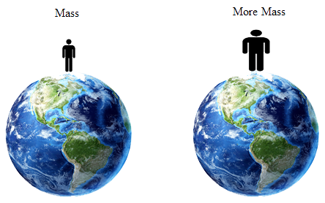

*Q: Does the mass of a planet influence its gravitational pull?*

*Hyp*: What do you think? Why?

**Hypothetical Test 2**:

You stepped on a triple beam balance here at Utah and found your mass to be 1000 kg, and later stepped on a scale and found your weight to be 100 N. What do you think would happen to both your mass & weight in the different locations? Indicate what you think will happen with an up or down arrow (**↑↓**), or an “X” if you think there will be no change.

|  |  |  |  |
| --- | --- | --- | --- |
|  | **Earth**  **Mass Fixed** | **Moon**  **(Has Less Mass ↓)** | **Jupiter**  **(Has More Mass ↑)** |
| **Your Mass**  (Matter) | 100 kg |  |  |
| **Your Weight**  (Attraction) | 980 N |  |  |

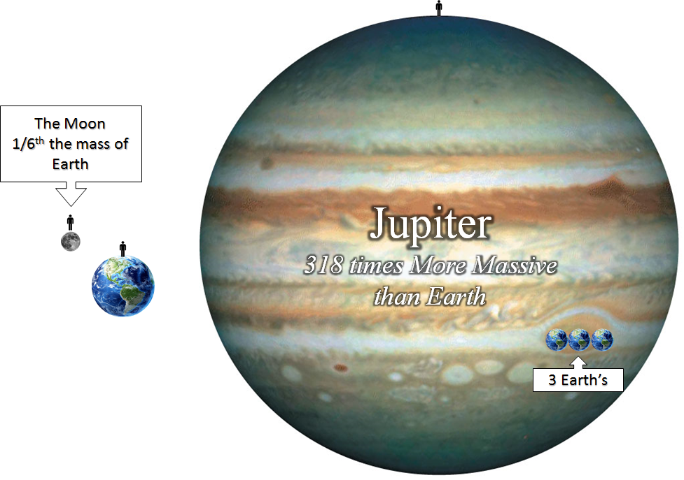

**Conclusion**: How does the mass of different planets influence gravitational pull & your weight?

*Q: Does distance influence gravity?*

*Hyp*: What do you think? Why?

**Lab Activity Test 3:** Sliding Attracted Magnets (Lab)

The fields of gravity are similar to the magnetic fields of a magnet. In this experiment, you will observe how unseen force fields affect one another.

Take two magnets and have them a considerable distance apart. Have one magnet laying at the 5 cm mark, while the other magnet is tightly clutched in your other hand near the 20 cm mark. Slowly drag the one in your hand (20 cm) towards the one at the 5 cm mark. When the magnets are attracted and slide out of your hand – calculate the distance the magnet traveled by its self.

N S

N S

|  |  |  |
| --- | --- | --- |
| Trial No. | The distance the magnet traveled. | Average Distance |
| Trial 1: |  |  |
| Trial 2: |  |

**Lab Activity Test 2**: Force of Attraction

Now, I want you to feel the amount of attraction between these two magnets as we increase the distance between them.

|  |  |
| --- | --- |
| **Distance Apart** | **Feel of Tug as you try to pull it apart** |
| Together 0.0 cm |  |
| Roughly 0.5 cm |  |
| Roughly 1 cm |  |
| Roughly 5 cm |  |

**Conclusion**: How does distance affect two magnetically attracted bodies?

**Analogy**: Gravity is ***NOT*** a magnetic force but it is similar to it. How is the magnetic attraction between two magnets similar to gravitational attraction between two objects with mass?

**Hypothetical Test 2**: Like two magnets, the earth and you are more attracted the closer you are.

In this case, what do you think will happen to both your mass and weight in these two scenarios? Indicate what you think will happen with an up or down arrow (**↑↓**), or an “X” if you think there will be no change.

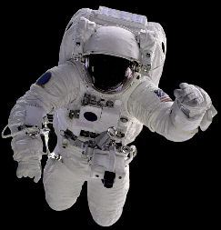

|  |  |  |  |
| --- | --- | --- | --- |
|  | **Utah** | **Europe** | **Space** |
| **Mass** | 100 kg |  |  |
| **Weight** | 980 N |  |  |

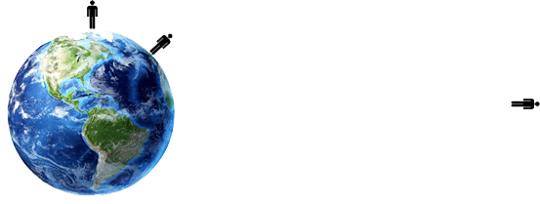

**Conclusion**: How does distance influence the effects of gravity?

**Part 3: Gravity & Acceleration /21**

*Q: How does the force of gravity affect the acceleration of an object?*

**Hypothetical Test 1**: A roller coaster is about to descend from its top. Compared to earth, how would that roller coaster behave on these different scenarios? (2pt ea)

|  |  |  |
| --- | --- | --- |
| **Space** | **Moon** | **Jupiter** |
|  |  |  |

1. Would the Roller Coaster descend differently on each scenario? Why?
2. Would you say that the roller coaster accelerates down in each scenario? If not, where would it be different?

**Hypothetical test 2**: If I let go and dropped an object from a high place in all three places, would it continually get faster and faster (accelerate), would it be a constant velocity, or would it just sit there?

|  |  |  |  |
| --- | --- | --- | --- |
| **Earth** | **Space** | **Moon** | **Jupiter** |
|  |  |  |  |

**Hypothetical Test 3**: Based on your answers above, in terms of “greater than” or “less than”, how would you describe the acceleration rates (how fast an object falls) of each compared to that of earths?

|  |  |  |
| --- | --- | --- |
| **Space** | **Moon** | **Jupiter** |
|  |  |  |

1. Would the acceleration rates be different for each environment? If no, why? If yes what do you hypothesize creates that difference?

**Conclusion**: Based on the results of the hypothetical tests and the formula for force: (Force = Mass x Acceleration), answer the original question:  *How does the force of gravity affect the acceleration of an object?*

**Part 4: Falling Objects in Gravitational Fields (Lab) /41**

*Q: Do all objects fall at the same rate? If not, what factors affect the rate of decent?*

*Hypothesis:*

How would you design an experiment concerning falling objects in gravity fields based on the following material items?

**Materials**:

* 1 Bowling Ball (Medium volume & heavy mass)
* 1 Basket Ball (Medium volume & Medium mass)
* 1 Beach Ball (Large volume & Low mass)
* 1 Tennis Ball (Small volume & Medium mass)
* 1 Bouncy Ball (Small volume & Small mass)
* Density Cube Set were the cubes are exactly the same, but the mass is different. This set includes:
  + Metals: Aluminum, Brass, Copper, Iron
  + Man Made Materials: Nylon, Acrylic
  + Woods: Pine, Oak, Poplar

**Experimental Design**:

Without the aid of a timer – briefly describe how would you test out your hypothesis – using only the materials listed?

**Lab Activity Test 1**: Same size (control), different mass (independent) [density cubes].

Cube 1

Cube 2

Book or Board

In this test, first take the mass of the two different cubes, then put the two different cubes at the edge of the book. Finally, tilt the book to drop the cubes at the same time.

|  |  |  |  |  |  |  |
| --- | --- | --- | --- | --- | --- | --- |
| **Mass of cube A** | |  | **Mass of Cube B** | |  | **Which cube hit first?**  **A, B or Both** |
| **Copper Metal** |  |  |  |  |  |  |
| **Copper Metal** |  |  |  |  |  |  |
| **Copper Metal** |  |  |  |  |  |  |

**Conclusion**: According to your data, is your hypothesis correct thus far? If not, create an explanation for the phenomenon you just encountered.

In these next few tests – do exactly the same thing as above: take the two objects and drop them off at the same time.

**Lab Test 2**:WhichHypothesis are we testing?

|  |  |  |
| --- | --- | --- |
| **Object 1:** | **Object 2:** | **Which Object hit first?** |
|  |  |  |

**Conclusion**: According to your data, is your hypothesis correct thus far? If not, create an explanation for the phenomenon you just encountered.

**Lab Test 3:** WhichHypothesis are we testing?

|  |  |  |
| --- | --- | --- |
| **Object 1:** | **Object 2:** | **Which Object hit first?** |
|  |  |  |

**Conclusion**: According to your data, is your hypothesis correct thus far? If not, create an explanation for the phenomenon you just encountered.

**Lab Test 4:** WhichHypothesis are we testing?

|  |  |  |
| --- | --- | --- |
| **Object 1:** | **Object 2:** | **Which Object hit first?** |
|  |  |  |

**Conclusion**: According to your data, is your hypothesis correct thus far? If not, create an explanation for the phenomenon you just encountered.

**Lab Test 5:** WhichHypothesis are we testing?

|  |  |  |
| --- | --- | --- |
| **Object 1:** | **Object 2:** | **Which Object hit first?** |
|  |  |  |

**Conclusion**: According to your data, is your hypothesis correct thus far? If not, create an explanation for the phenomenon you just encountered.

**Video Test 6:** WhichHypothesis are we testing?

|  |  |  |
| --- | --- | --- |
| **Mass Hammer** | **Mass Feather** | **Which object hit first?** |
|  |  |  |

**Conclusion**: According to your data, is your hypothesis correct thus far? If not, create an explanation for the phenomenon you just encountered.

**Bonus Question** (4): Based on your research – see if you can answer the following bonus question…

If gravity is a force, and it makes things accelerate downward towards the surface of the earth, what would happen if I dropped a bullet and shot another bullet horizontally at the same time, would they both hit the ground at the same time? Explain your reasoning.

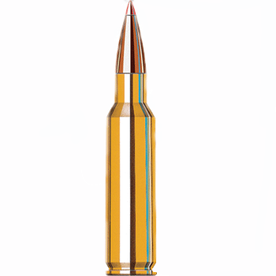

Dropped / Shot

**Part 5: Mass & Weight (Lab) /44**

*Q: Are mass and weight the same thing?*

*HYP: What do you think & why?*

**Pre Lab Questions:**

Use your text book to answer the following 2 terms:

1. What is mass, and what unit do we use to measure it?
2. What is weight, and what unit do we use to measure it?

**Pre Lab Activity:**

Use the diagrams to describe how each instrument works, determine what they measure & what units they use. The Arrows describes gravity.

**Metric Bathroom Scale:**

When you put an object on this – how and why does this measure weight?

Unit:

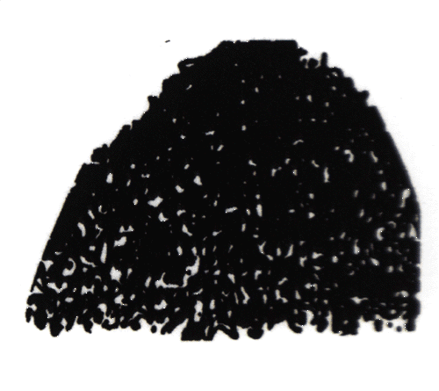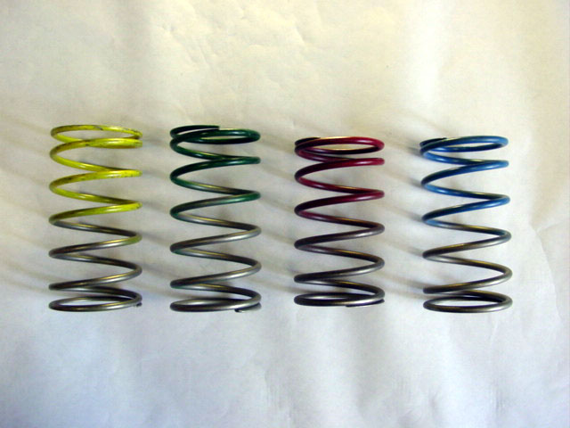

**Question:**

1. What does this instrument measure? __________________________
2. Would this machine give you the same number if you took this to the moon? If not, would it be higher or lower than earth?

1. Would this machine give you the same number if you took this to Jupiter? If not, would it be higher or lower than earth?

**Metric Force Meter:**

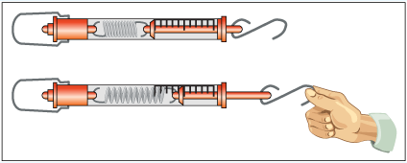

When you put an object on this - how & why does this measure weight?

Unit:

**Question:**

1. What does this instrument measure? __________________________
2. Would this machine give you the same number if you took this to the moon? If not, would it be higher or lower than earth?
3. Would this machine give you the same number if you took this to Jupiter? If not, would it be higher or lower than earth?

**Triple Beam Balance:**

When you put an object on this – how or why does this measure mass and not weight?

Unit:

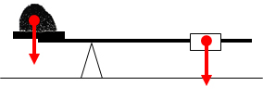

**Question:**

1. What does this instrument measure? __________________________
2. Would this machine give you the same number if you took this to the moon? If not, would it be higher or lower than earth?
3. Would this machine give you the same number if you took this to Jupiter? If not, would it be higher or lower than earth?

**Lab Activity:**

Place objects on the instruments and record your findings. DON’T FORGET YOUR UNITS! Calculate the ratio between the triple beam balance and the force meter, then round them to the nearest one’s placement or digit.

|  |  |  |  |
| --- | --- | --- | --- |
| **Objects** | **Force Meter**  **Weight [N]** | **Triple Beam Balance**  **Mass**  [convert g to Kg by moving the decimal over three places to the left] | **Ratio**  **(Force Meter : Balance)** |
| Mass 1: 500 g |  |  |  |
| Mass 2: 200 g |  |  |  |
| Mass 3: 100 g |  |  |  |
| Block |  |  |  |

**Questions:**

1. What do you notice about the ratio between the force meters and the triple beam balance?
2. Will these objects have mass if found in outer space?
3. Will these objects have weight if found in outer space?

1. Which variable is dependent upon gravity: mass or weight?

**Conclusion:**

1. Are mass and weight the same thing?

**Part 6: Weight /17**

*Q: Is weight a force? Provide your reasoning.*

*H:*

**Questions:**

1. When you want to find out how much force is needed to move an object, what instrument do you use to measure force with? What is the unit of measurement?
2. When you want to find out how much force you are pulling when you are playing “tug of war” what instrument would you use? What is the unit of measurement?
3. When you dangle an object on a force meter – what is pulling it down? _____________
4. Can you measure the strength of whatever is pulling that object? If so, how? What unit of measurement is that?
5. In an earlier lab, you already felt the tug between two magnets. Imagine you had only one magnet – would you feel a tug then? Why or why not?
6. Notice that you can only feel a tug when you have another magnet close by. That tug is one magnets attraction to another magnet. Can you measure the strength of that tug between those two magnets? A tug is a pull: what instrument do we use to measure a pull?
7. That tug between two magnets is similar to the tug of the earth to you. You call that “tug” - “gravity” as it pulls you down. As gravity pulls you down, you can measure the strength of the attraction between you and the earth. What instrument would you use to measure the strength of the pull – and what is the metric unit you would use to measure that by?

**Conclusion**: Is weight a force? If so, what unit do we use to measure weight by? If weight is not a force, what unit would you use to measure weight by?

**Part 7: Environmental Influence on Inertia & Force /31**

*Q: Does inertia change in different environments?*

*Hyp: What do you think & why?*

If inertia is the resistance to the “push or pull” of the force, then let’s see if we would receive a different result in three different environments.

**Hypothetical Test 1**: Differences of mass

If you were on a slippery surface, how easy would it be to push these items here on earth?

|  |  |
| --- | --- |
| **Items** | **Easiness of Push** |
| Base Ball |  |
| Diesel Truck |  |
| Space Station |  |

1. Why do you think this might make it harder or easier to push these items?

**Hypothetical Test 2**: Removing the Variables of Gravity & Friction – Same Mass

Most students feel that the reason an item might be difficult to move a heavy item is because of friction and gravity. Let’s run this hypothetical test to see if the results are different.

Imagine a diesel truck hanging on a long wire. You are required to push it while on a *skateboard*. Describe in the data table below how easy you feel it is to push it. In other words, which object is most likely to move backwards – you or the truck?

Next, we take that same truck and put it in space and the ice. You are required to push it again. Below, describe how easy it is to push the same object and what happens to either you or the truck when you push it in these environments.

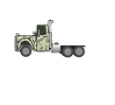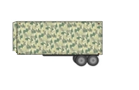

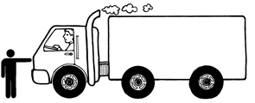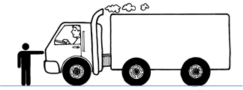



You and the truck are both out in space

You and the truck are both on ice

You are on a skateboard and the truck is on a chain hooked to the ceiling

|  |  |  |
| --- | --- | --- |
| **Location** | **What would happen to you after you pushed the truck?** | **What would happen to the truck after you pushed the truck?** |
| On Skateboard & String |  |  |
| On Ice |  |  |
| In Space |  |  |

**Question:**

1. What makes the difference of pushing the truck on a string and pushing the truck in space?
2. In your minds eye, what happens to you pushing the truck on ice?
3. Why would pushing the truck on ice be similar to pushing the truck in space?
4. Do you think the results would be different if you were to push the space station in all three scenarios? If so, why? If not, why not?

**Conclusion**: Answer the original question:  *Does inertia (or resistance to your push) change in different environments?* Give your reasoning.

Use the following key words to describe the following diagrams. (Gravity, Weight, Mass)

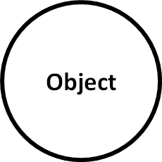

___________________________

An object made of atoms and molecules also has:

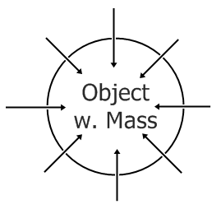

___________________________

The fields of attraction are called:

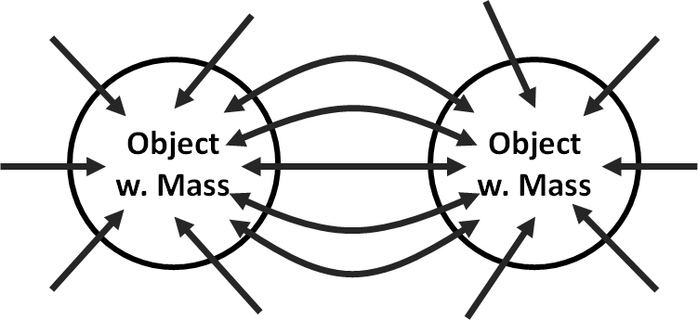

___________________________

It’s what happens when you get two objects with mass close enough and become attracted to each other

OVERALL IDEA:

Use the boxes to fill in the scenario blanks below:

1. Every object with mass also has gravity.
2. Every object with mass has gravity. When you have two objects with mass with gravity close enough together, they experience the attractive force of gravity called weight.

**Final Question:**

**Are mass and weight the same thing? Please explain:**

**Part 8: Earth’s Acceleration Rate (Lab) /12**

***Background****: According to part 4 - All objects fall at the same rate of acceleration (with the exception of air friction).*

***Q.*** *What is the acceleration rate of earth?*

**Lab Procedures:**

1. Find the distance of the school lunchroom balcony.
2. Drop a ball like object off the school lunchroom balcony and time it. (7)

|  |  |  |  |
| --- | --- | --- | --- |
| **Height** |  | **Trial** | **Time** |
|  |  | **1** |  |
|  |  | **2** |  |
|  |  | **3** |  |
|  |  | **4** |  |
|  |  | **5** |  |
|  |  | **Average** |  |

1. Next: Plug in those numbers to calculate the acceleration rate of the earth into the acceleration formula for free falling objects: (3)

.

**Conclusion:** (2)

**Theory of Gravity**

/20

In light of all of the evidence and data you collected from these lab tests, please write a short essay describing your theory of how gravity works. Be sure to answer the question what factor gives any object gravity, what factors influence gravity, what weight is, the difference between mass and weight, and where does gravity pull all objects towards. I’m really interested in the correlation or relationship scenarios – like when something goes up, the other something goes up – or, when you have more of something, you have less of another.

It helps to examine all your lab tests & conclusions, synthesize them all together, and then prepare to explain it to someone in 7th grade.

Start off with a free-write, cluster, list or other pre-writing activity to gather your thoughts. Organize your thoughts, and then write a semi-final draft on this page. I’m not worried about grammar as much as content and thoughts; the more details, the better. Give me something worth 20 points.

As you do your free write, consider what you learned in each part, and then add it to your theory: